**Create a Schema**

CREATE SCHEMA SK3395_FALL2022;

**CREATE A TABLE BRANCH**

create table sk3395_fall2022.BRANCH (

BRANCH_ID VARCHAR(50) NOT NULL,

BRANCH_NAME VARCHAR(50) NOT NULL,

CITY VARCHAR(50) NOT NULL,

ADDRESS VARCHAR(50) NOT NULL,

DISTRICT VARCHAR(50) NOT NULL,

STATE VARCHAR(50) NOT NULL,

MANAGER_NAME VARCHAR(50),

PRIMARY KEY(BRANCH_ID),

UNIQUE(BRANCH_NAME)

);

**Inserting values into branch table**

insert into sk3395_fall2022.BRANCH(BRANCH_ID ,BRANCH_NAME ,CITY ,ADDRESS ,DISTRICT ,STATE ,MANAGER_NAME ) values('SB001','bazar branch','portwills','25-crossroad','hamsberg','newbrook','tims');

insert into sk3395_fall2022.BRANCH(BRANCH_ID ,BRANCH_NAME ,CITY ,ADDRESS ,DISTRICT ,STATE ,MANAGER_NAME ) values('SB002','main branch','hillwills','43-hillroad','clinton','newhill','bob');

insert into sk3395_fall2022.BRANCH(BRANCH_ID ,BRANCH_NAME ,CITY ,ADDRESS ,DISTRICT ,STATE ,MANAGER_NAME ) values('SB003','speedy branch','wayne','57-dukeroad','willowkin','kitaa','john');

insert into sk3395_fall2022.BRANCH(BRANCH_ID ,BRANCH_NAME ,CITY ,ADDRESS ,DISTRICT ,STATE ,MANAGER_NAME ) values('SB004','ruble branch','kinglanton','55-ricketon','pituffik','new tunu','marry');

insert into sk3395_fall2022.BRANCH(BRANCH_ID ,BRANCH_NAME ,CITY ,ADDRESS ,DISTRICT ,STATE ,MANAGER_NAME ) values('SB005','bay branch','victoria','95-wickroad','derby','wiluna','mike');

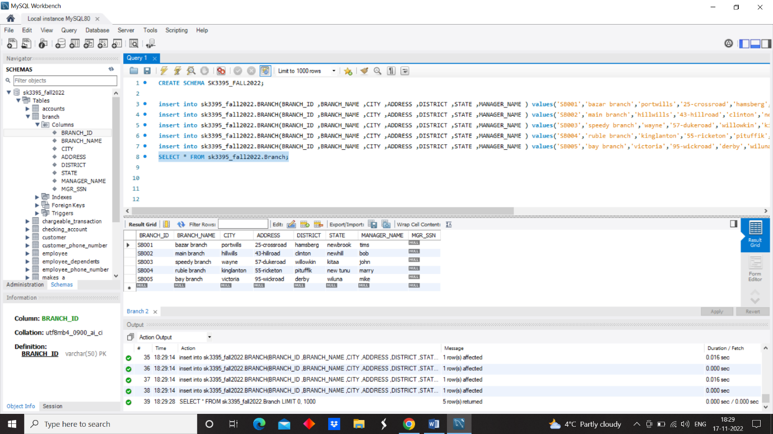

Update branch set branch_name=”bulls branch” where branch_id=”sb005”.

Delete from branch where branch_id=’sb002’.

**CREATE A TABLE EMPLOYEE**

create table sk3395_fall2022.EMPLOYEE (

SSN VARCHAR(30) NOT NULL,

FIRST_NAME VARCHAR(50) NOT NULL,

MIDDLE_NAME VARCHAR(50),

LAST_NAME VARCHAR(50) NOT NULL,

START_DATE DATE NOT NULL,

SEX VARCHAR(50),

SALARY DECIMAL(50),

ADDRESS VARCHAR(50),

SUPER_SSN VARCHAR(50),

EMP_BRANCH_ID VARCHAR(50),

PRIMARY KEY(SSN),

FOREIGN KEY(EMP_BRANCH_ID) references sk3395_fall2022.branch(BRANCH_ID) ON DELETE SET NULL,

FOREIGN KEY(SUPER_SSN) REFERENCES sk3395_fall2022.EMPLOYEE(SSN) ON DELETE SET NULL

);

insert into sk3395_fall2022.employee values('A12389','tims',null,'wood','2021-04-22','M',95000,'23-willow boomligton',null,'SB001');

insert into sk3395_fall2022.employee values('A21322','bob','billy','rick','2018-09-29','M',110000,'42-billow newloogton',null,'SB002');

insert into sk3395_fall2022.employee values('A12422','john',null,'smith','2020-07-18','M',150000,'33-rickslog hamstron',null,'SB003');

insert into sk3395_fall2022.employee values('A23213','marry',null,'eagon','2020-05-09','F',125000,'14-cleveton morries',null,'SB004');

insert into sk3395_fall2022.employee values('A14736','mike','harry','cena','2021-09-18','M',105000,'17-rory will',null,'SB005');

insert into sk3395_fall2022.employee values('A14999','will',null,'hunter','2020-03-14','M',88000,'1-roryhill','A14736','SB005');

insert into sk3395_fall2022.employee values('A14788','emma',null,'gill','2017-09-20','F',85000,'7-cleveton hill','A23213','SB004');

insert into sk3395_fall2022.employee values('A14991','zane',null,'huke','2019-09-09','M',95000,'36-rickslog hamstron','A12422','SB003');

insert into sk3395_fall2022.employee values('A14119','harry',null,'mill','2021-01-07','M',98000,'21-billow newloogton','A21322','SB002');

insert into sk3395_fall2022.employee values('A14339','hope',null,'mikelson','2021-11-25','F',85000,'11-willow boomlington','A12389','SB001');

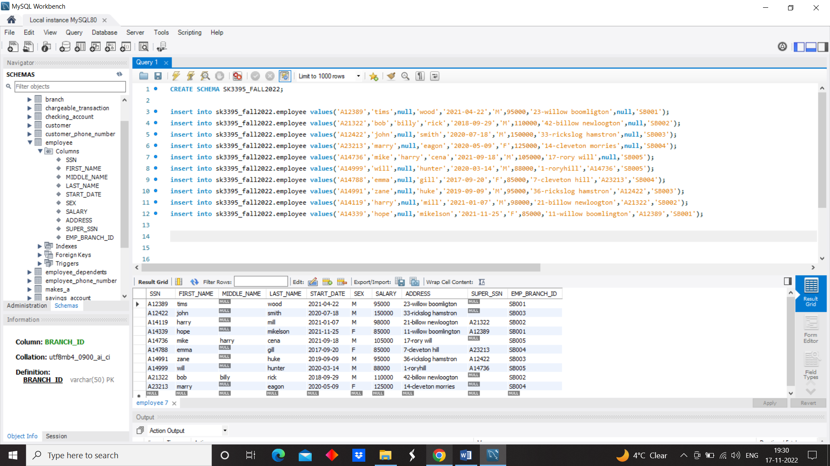

Update employee set middle_name=”bill” where first_name=”tims”.

Delete from employee where ssn=’A12422’.

**CREATING A COLUMN (MGR_SSN) IN BRANCH AND MAKING IT AS FOREIGN KEY**

ALTER TABLE sk3395_fall2022.branch

ADD MGR_SSN VARCHAR(50) ;

ALTER TABLE sk3395_fall2022.branch

ADD FOREIGN KEY(MGR_SSN) REFERENCES sk3395_fall2022.employee(SSN) ON delete SET NULL;

UPDATE sk3395_fall2022.branch SET MGR_SSN = 'A12389' WHERE BRANCH_ID = 'SB001';

UPDATE sk3395_fall2022.branch SET MGR_SSN = 'A21322' WHERE BRANCH_ID = 'SB002';

UPDATE sk3395_fall2022.branch SET MGR_SSN = 'A12422' WHERE BRANCH_ID = 'SB003';

UPDATE sk3395_fall2022.branch SET MGR_SSN = 'A23213' WHERE BRANCH_ID = 'SB004';

UPDATE sk3395_fall2022.branch SET MGR_SSN = 'A14736' WHERE BRANCH_ID = 'SB005';

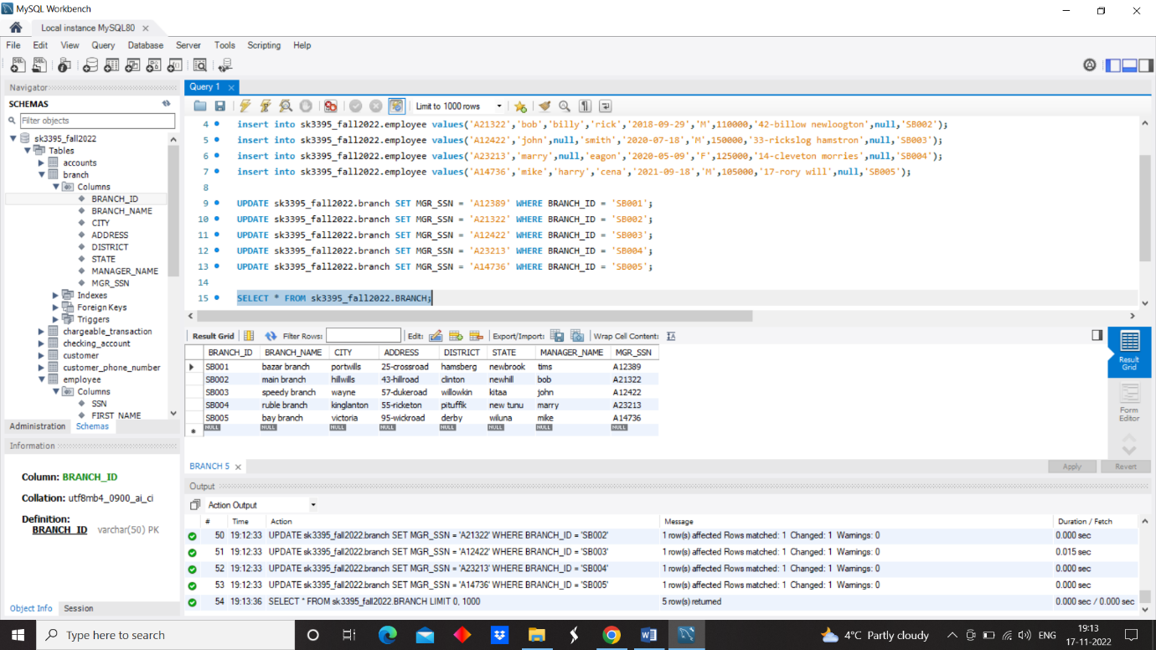

**CREATE A TABLE EMPLOYEE_DEPENDENTS**

create table sk3395_fall2022.EMPLOYEE_DEPENDENTS (

EMP_SSN VARCHAR(30),

DEPEDENT_NAME VARCHAR(50) NOT NULL,

BIRTH_DATE DATE,

SEX CHAR(10),

RELATIONSHIP VARCHAR(50) NOT NULL,

FOREIGN KEY(EMP_SSN) REFERENCES sk3395_fall2022.EMPLOYEE(SSN) ON DELETE CASCADE,

PRIMARY KEY(EMP_SSN,DEPEDENT_NAME) );

insert into sk3395_fall2022.employee_dependents values('A12389','HENRY','1991-09-22','M','BROTHER');

insert into sk3395_fall2022.employee_dependents values('A14339','JIM','1981-08-12','M','FATHER');

insert into sk3395_fall2022.employee_dependents values('A14119','PAUL','1997-02-22','M','BROTHER');

insert into sk3395_fall2022.employee_dependents values('A21322','LENA','1980-03-19','F','MOTHER');

insert into sk3395_fall2022.employee_dependents values('A23213','TURNER','1997-09-29','M','BROTHER');

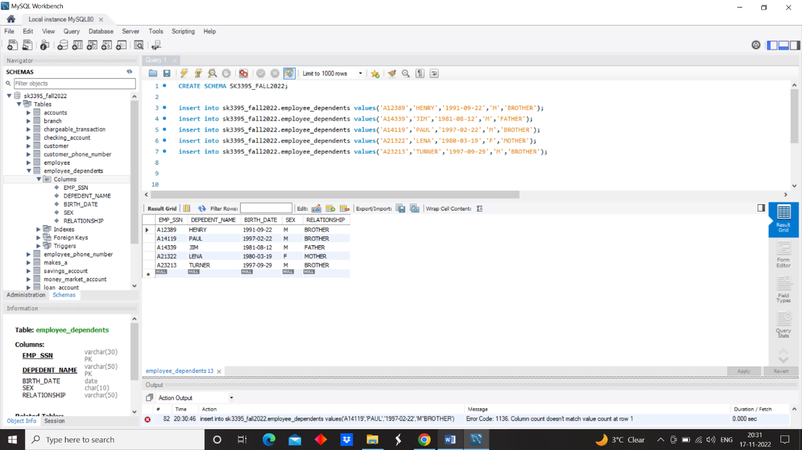

Update employee_dependents set first_name=”hunter” where first_name=”henry”.

Delete from employee_dependents where first_name=’paul’.

**CREATE A TABLE EMPLOYEE_PHONE_NUMBER**

create table sk3395_fall2022.EMPLOYEE_PHONE_NUMBER (

EMP_SSN VARCHAR(30),

EMP_NUMBER VARCHAR(20) NOT NULL UNIQUE,

FOREIGN KEY(EMP_SSN) REFERENCES sk3395_fall2022.EMPLOYEE(SSN) ON DELETE CASCADE,

PRIMARY KEY(EMP_SSN,EMP_NUMBER)

);

insert into sk3395_fall2022.employee_phone_number values('A12389','+1 9845638373');

insert into sk3395_fall2022.employee_phone_number values('A14339','+1 9347634634');

insert into sk3395_fall2022.employee_phone_number values('A14119','+1 9244546366');

insert into sk3395_fall2022.employee_phone_number values('A21322','+1 9364534765');

insert into sk3395_fall2022.employee_phone_number values('A12422','+1 9456784774');

insert into sk3395_fall2022.employee_phone_number values('A14991','+1 9475464846');

insert into sk3395_fall2022.employee_phone_number values('A14788','+1 9034478483');

insert into sk3395_fall2022.employee_phone_number values('A23213','+1 9182736367');

insert into sk3395_fall2022.employee_phone_number values('A14736','+1 9192837337');

insert into sk3395_fall2022.employee_phone_number values('A14999','+1 9182736345');

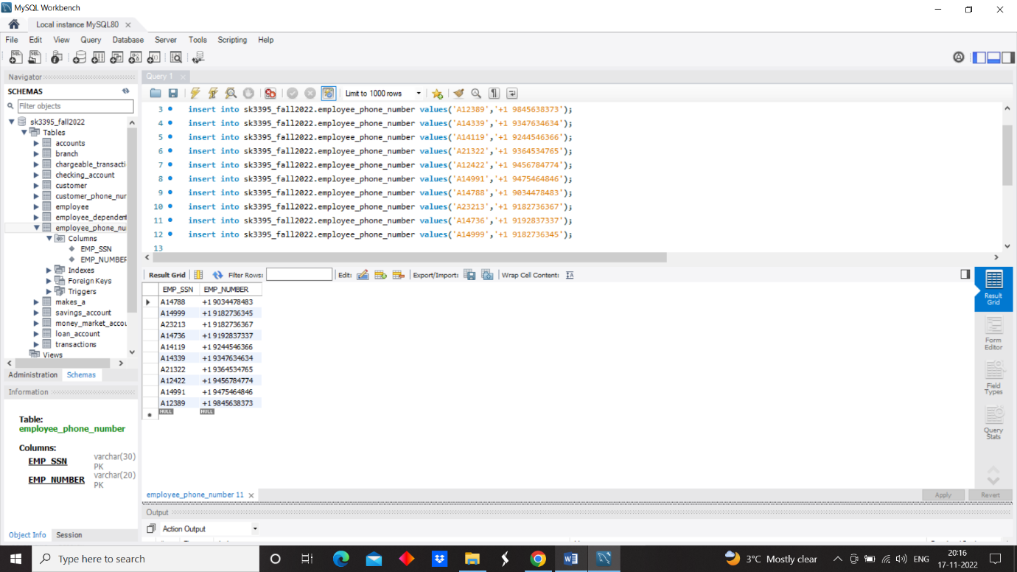

**CREATE A TABLE TRANSACTIONS**

create table sk3395_fall2022.TRANSACTIONS (

TRANSACTION_CODE VARCHAR(20) ,

AMOUNT INT NOT NULL,

DATE_AND_TIME_OF_TRANSACTION TIMESTAMP NOT NULL,

ACCOUNT_NUMBER VARCHAR(50) NOT NULL,

TYPE_OF_TRANSACTION VARCHAR(30) NOT NULL,

TRAN_BRANCH_ID VARCHAR(50),

FOREIGN KEY(TRAN_BRANCH_ID) REFERENCES sk3395_fall2022.BRANCH(BRANCH_ID) ON DELETE SET NULL,

PRIMARY KEY(TRANSACTION_CODE)

);

insert into sk3395_fall2022.transactions values('T12322',255,'2022-02-14 22:24:34','A4000','CASH WITHDRAWL','SB001');

insert into sk3395_fall2022.transactions values('T33221',120,'2022-09-12 12:11:10','A4500','CASH WITHDRAWL','SB002');

insert into sk3395_fall2022.transactions values('T03944',200,'2022-08-13 18:10:10','A5500','CASH DEPOSITE','SB001');

insert into sk3395_fall2022.transactions values('T01377',300,'2022-09-11 22:19:11','A4599','CASH DEPOSITE','SB003');

insert into sk3395_fall2022.transactions values('T93838',100,'2022-10-10 12:12:12','A5525','LOAN PAYMENT','SB004');

insert into sk3395_fall2022.transactions values('T03373',350,'2022-10-02 12:13:11','A3300','LOAN PAYMENT','SB005');

insert into sk3395_fall2022.transactions values('T83626',280,'2022-11-29 19:11:10','A3377','CASH WITHDRAWL','SB003');

insert into sk3395_fall2022.transactions values('T25777',420,'2022-10-22 13:14:19','A4900','CASH WITHDRAWL','SB004');

insert into sk3395_fall2022.transactions values('T38477',360,'2022-01-20 18:22:10','A4911','CASH WITHDRAWL','SB005');

insert into sk3395_fall2022.transactions values('T74647',290,'2022-10-10 19:29:55','A4011','CASH DEPOSITE','SB002');

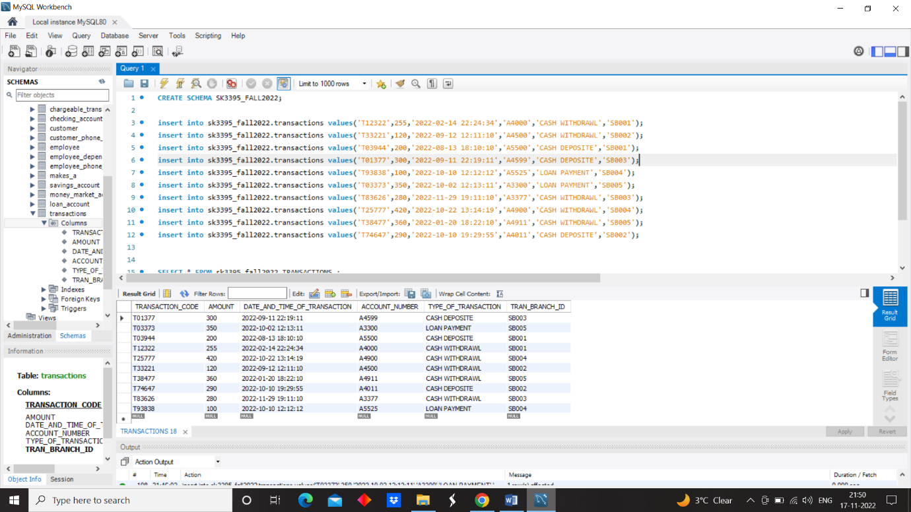

Update transactions set amount=1000 where transaction_code=”T01377”.

Delete from transactions where transaction_code =’T01377’.

**CREATE A TABLE CHARGEABLE_TRANSACTION**

create table sk3395_fall2022.CHARGEABLE_TRANSACTION (

CHARGE_ID VARCHAR(30) ,

TRANSACTION_CHARGE INT NOT NULL,

CH_TRANSACTION_CODE VARCHAR(50) NOT NULL UNIQUE,

FOREIGN KEY(CH_TRANSACTION_CODE) REFERENCES sk3395_fall2022.TRANSACTIONS(TRANSACTION_CODE) ON DELETE CASCADE,

PRIMARY KEY(CHARGE_ID)

);

insert into sk3395_fall2022.chargeable_transaction values('CH2323',25,'T83626');

insert into sk3395_fall2022.chargeable_transaction values('CH2938',30,'T25777');

insert into sk3395_fall2022.chargeable_transaction values('CH1122',10,'T38477');

Update CHARGEABLE_TRANSACTION set transaction_charge=15 where CH_transaction_code=”T38477”.

Delete from CHARGEABLE_TRANSACTION where transaction_charge =15.

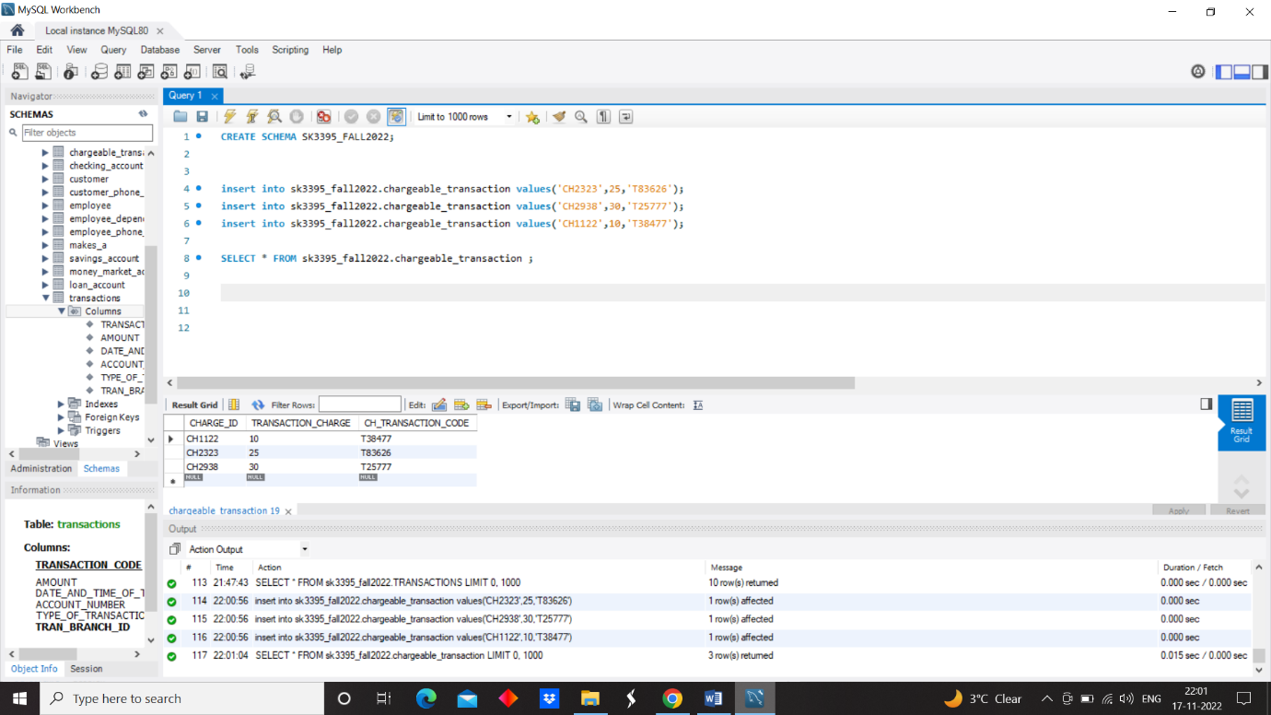

**CREATE A TABLE CUSTOMER**

create table sk3395_fall2022.CUSTOMER (

CUST_SSN VARCHAR(50) ,

CUST_NAME VARCHAR(50) NOT NULL,

STREET_NUMBER INT,

CITY VARCHAR(30),

STATE VARCHAR(40),

APT_NUMBER VARCHAR(40),

ZIP_CODE INT,

CUST_PERSONAL_BANKER_EMP_NAME VARCHAR(30),

EMP_SSN VARCHAR(30),

BRANCH_ID VARCHAR(50),

FOREIGN KEY(BRANCH_ID) REFERENCES sk3395_fall2022.BRANCH(BRANCH_ID) ON DELETE SET NULL,

FOREIGN KEY(EMP_SSN) REFERENCES sk3395_fall2022.EMPLOYEE(SSN) ON DELETE SET NULL,

PRIMARY KEY(CUST_SSN)

);

insert into sk3395_fall2022.customer values('A11922','MILLS',22,'portwills','newbrook','3-portwills',10079,'TIMS','A12389','SB001');

insert into sk3395_fall2022.customer values('A29383','JILL',32,'portwills','newbrook','4-portwills',10079,'hope','A14339','SB001');

insert into sk3395_fall2022.customer values('A09099','groot',82,'hillwills','newhill','2-hillwills',10009,'harry','A14119','SB002');

insert into sk3395_fall2022.customer values('A20003','hella',3,'hillwills','newhill','4-hillwills',10009,'bob','A21322','SB002');

insert into sk3395_fall2022.customer values('A09448','Jerry',36,'wayne','kitaa','4-wayne',10070,'john','A12422','SB003');

insert into sk3395_fall2022.customer values('A29000','tom',30,'wayne','kitaa','2-wayne',10070,'zane','A14991','SB003');

insert into sk3395_fall2022.customer values('A00123','gwen',100,'kinglanton','new tunu','4-kinglanton',10019,'emma','A14788','SB004');

insert into sk3395_fall2022.customer values('A00321','ben',110,'kinglanton','new tunu','2-kinglanton',10019,'marry','A23213','SB004');

insert into sk3395_fall2022.customer values('A09182','root',120,'victoria','wiluna','1-wiluna',10179,'mike','A14736','SB005');

insert into sk3395_fall2022.customer values('A02833','buttler',132,'victoria','wiluna','5-wiluna',10179,'will','A14999','SB005');

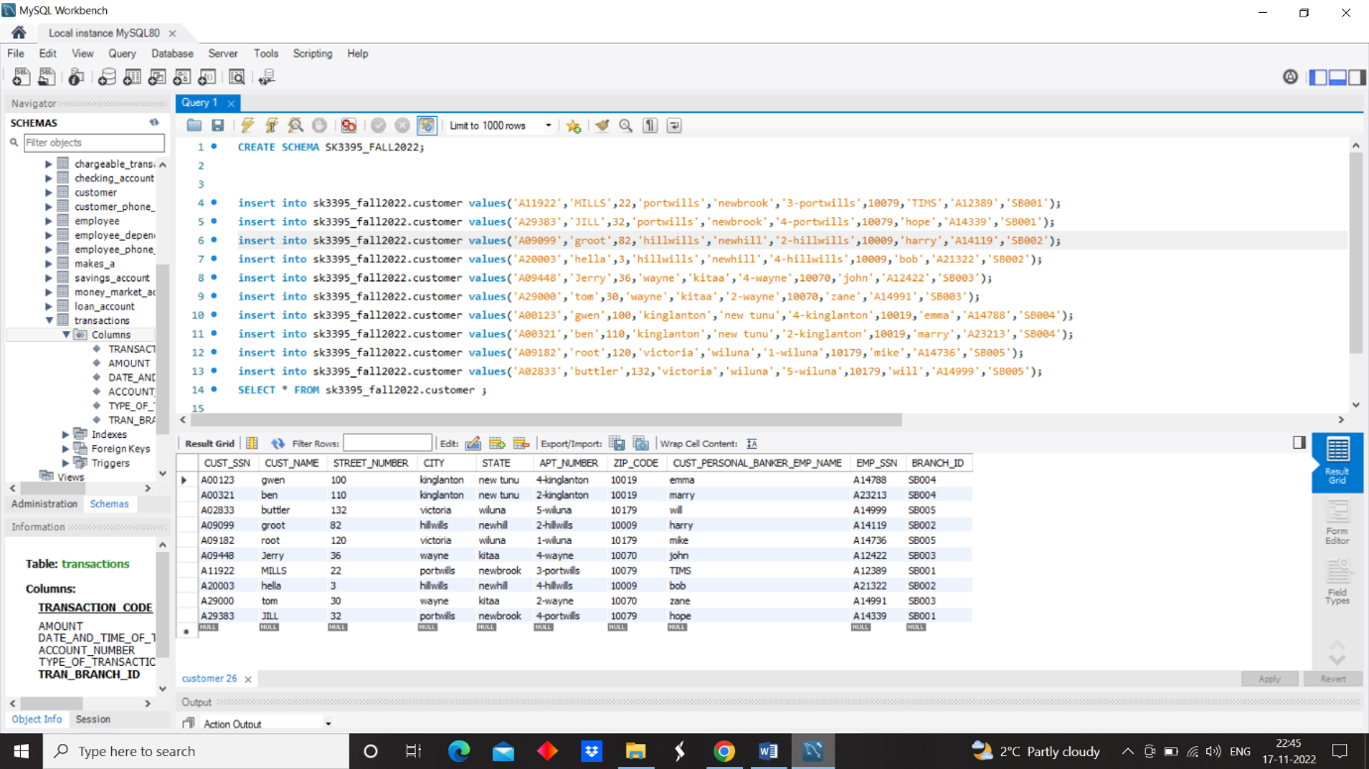

Update customers set cust_name=”P gwen” where cust_name=”gwen”.

Delete from customer where cust_name =”p gwen”.

**CREATE A TABLE CUSTOMER PHONE NUMBER**

create table sk3395_fall2022.CUSTOMER_PHONE_NUMBER (

CUST_SSN VARCHAR(50) ,

CUST_NUMBER VARCHAR(50) ,

FOREIGN KEY(CUST_SSN) REFERENCES sk3395_fall2022.CUSTOMER(CUST_SSN) ON DELETE CASCADE,

PRIMARY KEY(CUST_SSN,CUST_NUMBER)

);

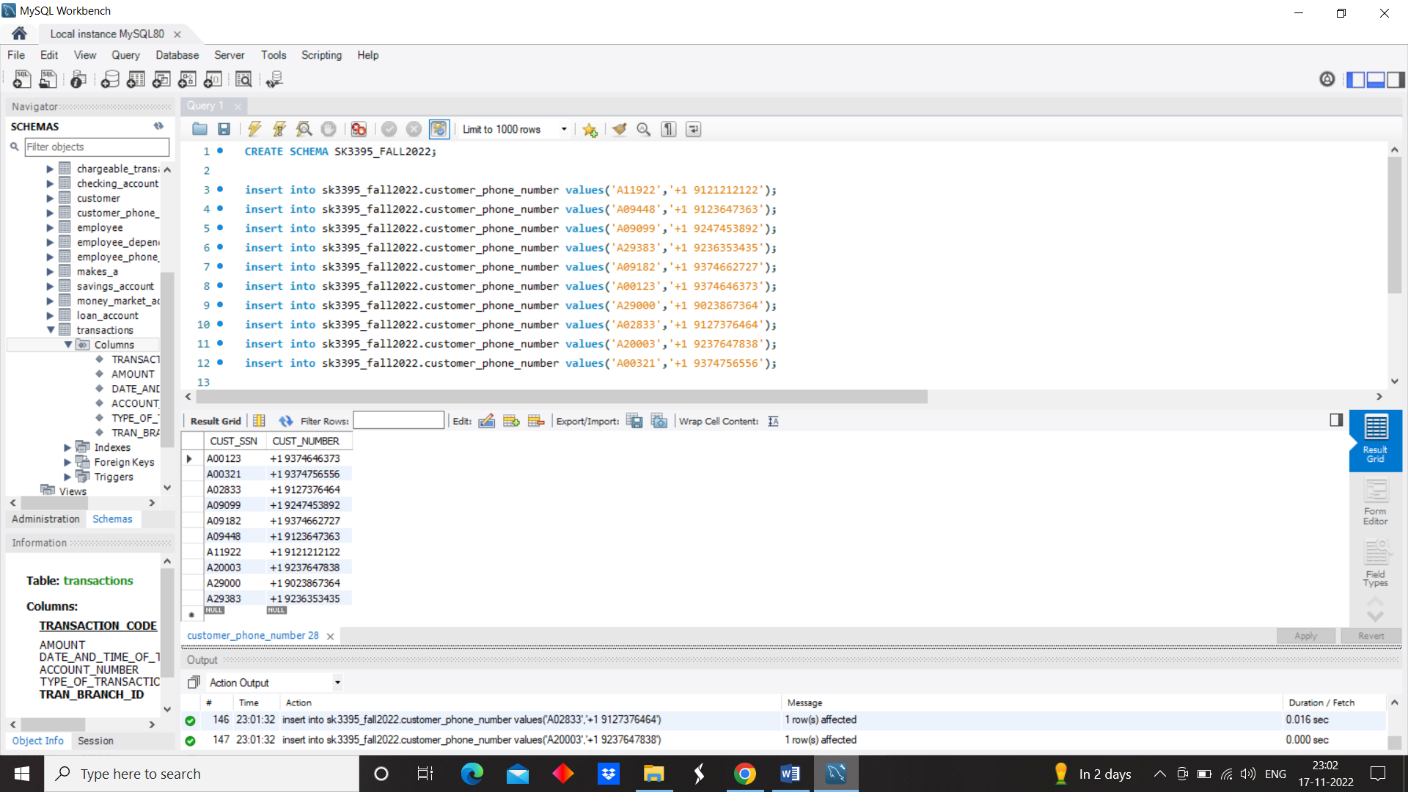

insert into sk3395_fall2022.customer_phone_number values('A11922','+1 9121212122');

insert into sk3395_fall2022.customer_phone_number values('A09448','+1 9123647363');

insert into sk3395_fall2022.customer_phone_number values('A09099','+1 9247453892');

insert into sk3395_fall2022.customer_phone_number values('A29383','+1 9236353435');

insert into sk3395_fall2022.customer_phone_number values('A09182','+1 9374662727');

insert into sk3395_fall2022.customer_phone_number values('A00123','+1 9374646373');

insert into sk3395_fall2022.customer_phone_number values('A29000','+1 9023867364');

insert into sk3395_fall2022.customer_phone_number values('A02833','+1 9127376464');

insert into sk3395_fall2022.customer_phone_number values('A20003','+1 9237647838');

insert into sk3395_fall2022.customer_phone_number values('A00321','+1 9374756556');

**CREATE A TABLE ACCOUNTS**

create table sk3395_fall2022.ACCOUNTS (

UNIQUE_ACCOUNT_NUMBER VARCHAR(50) ,

BRANCH_ID VARCHAR(50),

RECENTLY_ACCESSED_DATE TIMESTAMP,

ACCOUNT_BALANCE INT NOT NULL,

FOREIGN KEY(BRANCH_ID) REFERENCES sk3395_fall2022.BRANCH(BRANCH_ID) ON DELETE SET NULL,

PRIMARY KEY( UNIQUE_ACCOUNT_NUMBER)

);

insert into sk3395_fall2022.accounts values('A3300','SB005','2022-02-16 23:12:11',800);

insert into sk3395_fall2022.accounts values('A4011','SB002','2022-08-22 17:19:19',1000);

insert into sk3395_fall2022.accounts values('A4000','SB001','2022-04-17 19:59:22',1200);

insert into sk3395_fall2022.accounts values('A4599','SB003','2022-09-20 20:36:39',2500);

insert into sk3395_fall2022.accounts values('A4900','SB004','2022-07-29 09:40:28',950);

insert into sk3395_fall2022.accounts values('A4911','SB005','2022-09-12 13:13:01',900);

insert into sk3395_fall2022.accounts values('A4500','SB002','2022-07-24 07:59:39',1100);

insert into sk3395_fall2022.accounts values('A5500','SB001','2022-01-15 09:29:42',1400);

insert into sk3395_fall2022.accounts values('A3377','SB003','2022-01-20 23:46:59',2800);

insert into sk3395_fall2022.accounts values('A5525','SB004','2022-05-28 19:10:48',1950);

insert into sk3395_fall2022.accounts values('A4002','SB005','2022-01-1 21:45:12',1550);

insert into sk3395_fall2022.accounts values('A4001','SB004','2022-01-3 21:59:14',950);

insert into sk3395_fall2022.accounts values('A3007','SB002','2022-12-11 11:59:30',1150);

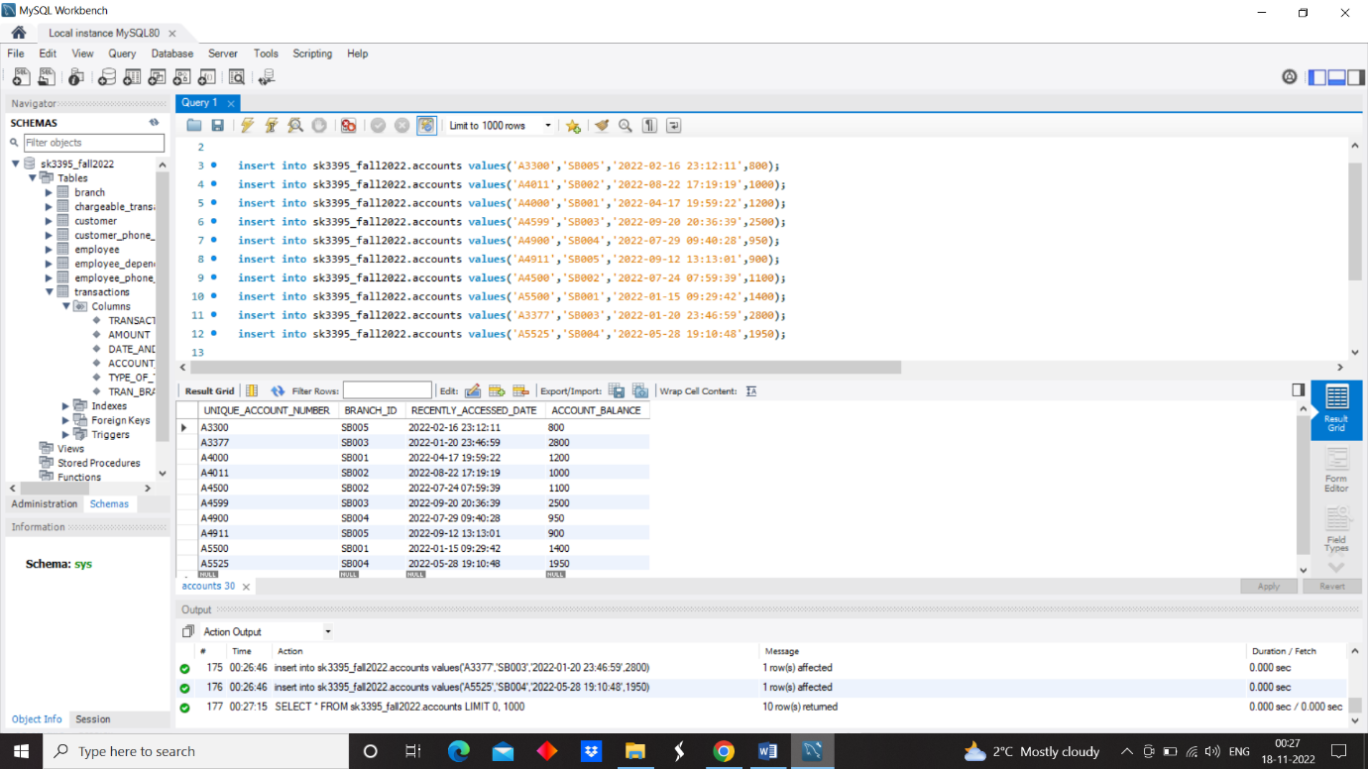

Update accounts set branch_id=sb003 where unique_account_number=”A3300”.

Delete from accounts where unique_account_number=”A3300”.

**CREATE A TABLE LOAN ACCOUNT**

create table sk3395_fall2022.LOAN_ACCOUNT (

ACCOUNT_NUMBER VARCHAR(50) ,

LOAN_NUMBER VARCHAR(50),

TYPE_OF_LOAN VARCHAR(50) NOT NULL,

LOAN_AMOUNT INT NOT NULL,

LOAN_MONTHLY_REPAYMENT_AMOUNT INT,

FIXED_INTEREST_RATE DECIMAL(6,4),

FOREIGN KEY(ACCOUNT_NUMBER) REFERENCES sk3395_fall2022.ACCOUNTS(UNIQUE_ACCOUNT_NUMBER) ON DELETE CASCADE,

PRIMARY KEY( ACCOUNT_NUMBER,LOAN_NUMBER)

);

insert into sk3395_fall2022.loan_account values('A5525','LN3422','house',60000,550,9.23);

insert into sk3395_fall2022.loan_account values('A3300','LN3242','car',35000,300,10.34);

Update loan_account set type_of_loan=’house’ where loan_number=”LN3242”.

Delete from loan_account where loan_number=”LN3242”.

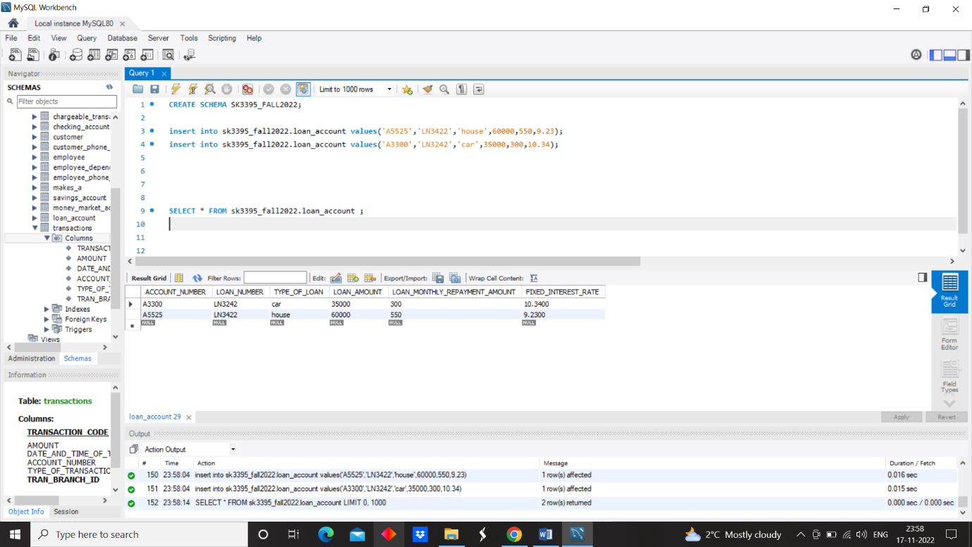

**CREATE A TABLE SAVINGS ACCOUNT**

create table sk3395_fall2022.SAVINGS_ACCOUNT (

ACCOUNT_NUMBER VARCHAR(50) ,

ACCOUNT_HOLDER_NAME VARCHAR(50),

FIXED_INTEREST_RATE DECIMAL(6,4),

FOREIGN KEY(ACCOUNT_NUMBER) REFERENCES sk3395_fall2022.ACCOUNTS(UNIQUE_ACCOUNT_NUMBER) ON DELETE CASCADE,

PRIMARY KEY( ACCOUNT_NUMBER,ACCOUNT_HOLDER_NAME)

);

insert into sk3395_fall2022.savings_account values('A4599','jerry',3.50);

insert into sk3395_fall2022.savings_account values('A5500','jill',3.50);

insert into sk3395_fall2022.savings_account values('A4000','mills',3.50);

insert into sk3395_fall2022.savings_account values('A4900','ben',3.50);

insert into sk3395_fall2022.savings_account values('A4500','hela',3.50);

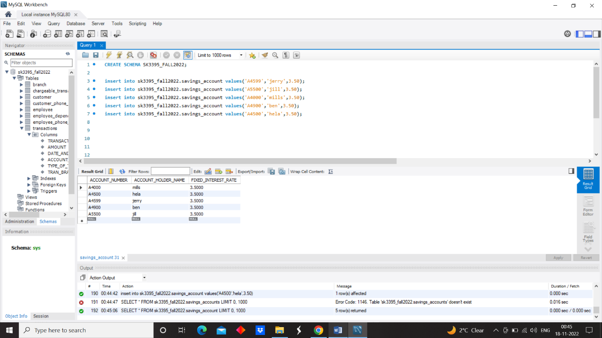

Update savings_account set Account_holder_name=’rick’ where Account_holder_name=”jill”.

Delete from savings_account where Account_holder_name=’rick’.

**CREATE A TABLE CHECKING ACCOUNT**

create table sk3395_fall2022.CHECKING_ACCOUNT (

ACCOUNT_NUMBER VARCHAR(50) ,

ACCOUNT_HOLDER_NAME VARCHAR(50),

OVERDRAFT DECIMAL(30,4),

FOREIGN KEY(ACCOUNT_NUMBER) REFERENCES sk3395_fall2022.ACCOUNTS(UNIQUE_ACCOUNT_NUMBER) ON DELETE CASCADE,

PRIMARY KEY( ACCOUNT_NUMBER,ACCOUNT_HOLDER_NAME)

);

insert into sk3395_fall2022.checking_account values('A4911','buttler',5.50);

insert into sk3395_fall2022.checking_account values('A4011','groot',5.50);

insert into sk3395_fall2022.checking_account values('A3377','tom',5.50);

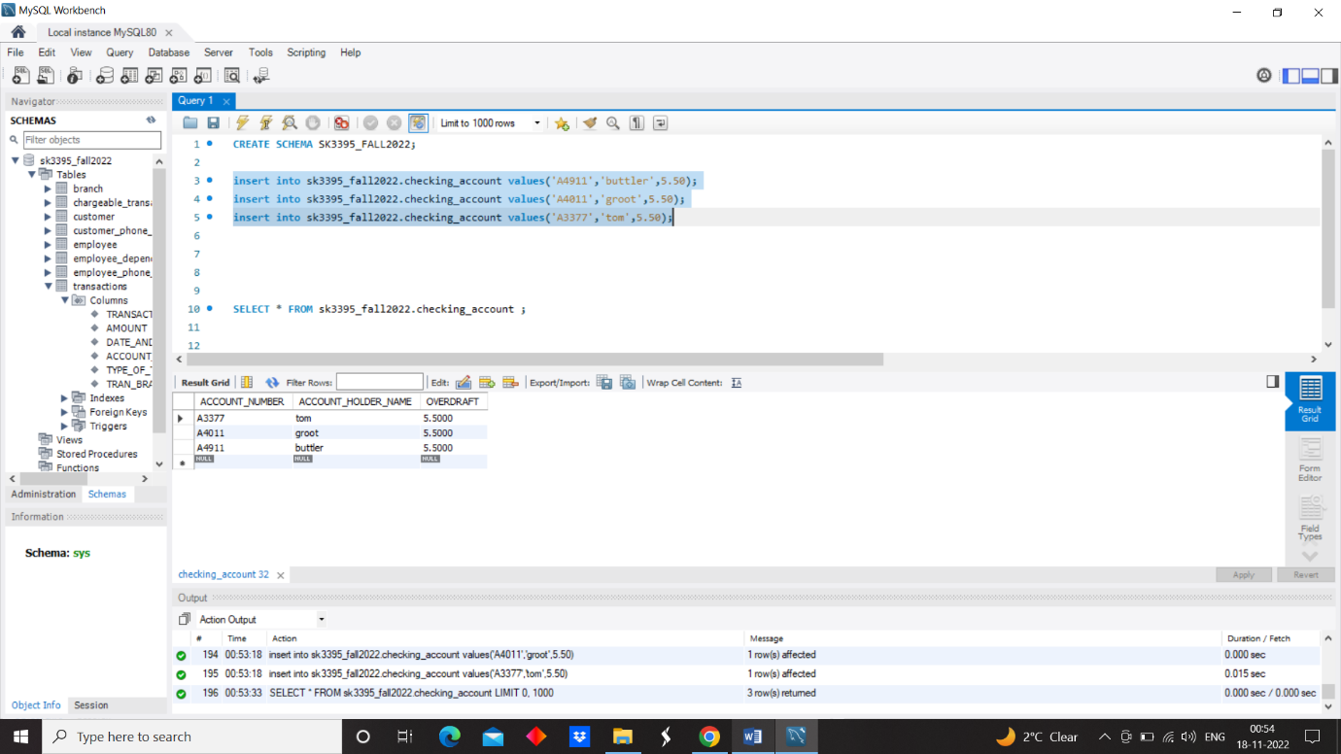

Update checking_account set Account_holder_name=’hunter’ where Account_holder_name=”tom”.

Delete from checking_account where Account_holder_name=’hunter’.

**CREATE A TABLE MONEY_MARKET_ACCOUNT**

create table sk3395_fall2022.MONEY_MARKET_ACCOUNT (

ACCOUNT_NUMBER VARCHAR(50) ,

ACCOUNT_HOLDER_NAME VARCHAR(50),

VARIABLE_INTREST_RATE DECIMAL(6,4),

FOREIGN KEY(ACCOUNT_NUMBER) REFERENCES sk3395_fall2022.ACCOUNTS(UNIQUE_ACCOUNT_NUMBER) ON DELETE CASCADE,

PRIMARY KEY( ACCOUNT_NUMBER,ACCOUNT_HOLDER_NAME)

);

insert into sk3395_fall2022.MONEY_MARKET_ACCOUNT values('A4002','buttler',9.50);

insert into sk3395_fall2022.MONEY_MARKET_ACCOUNT values('A4001','ben',9.50);

insert into sk3395_fall2022.MONEY_MARKET_ACCOUNT values('A3007','hela',9.50);

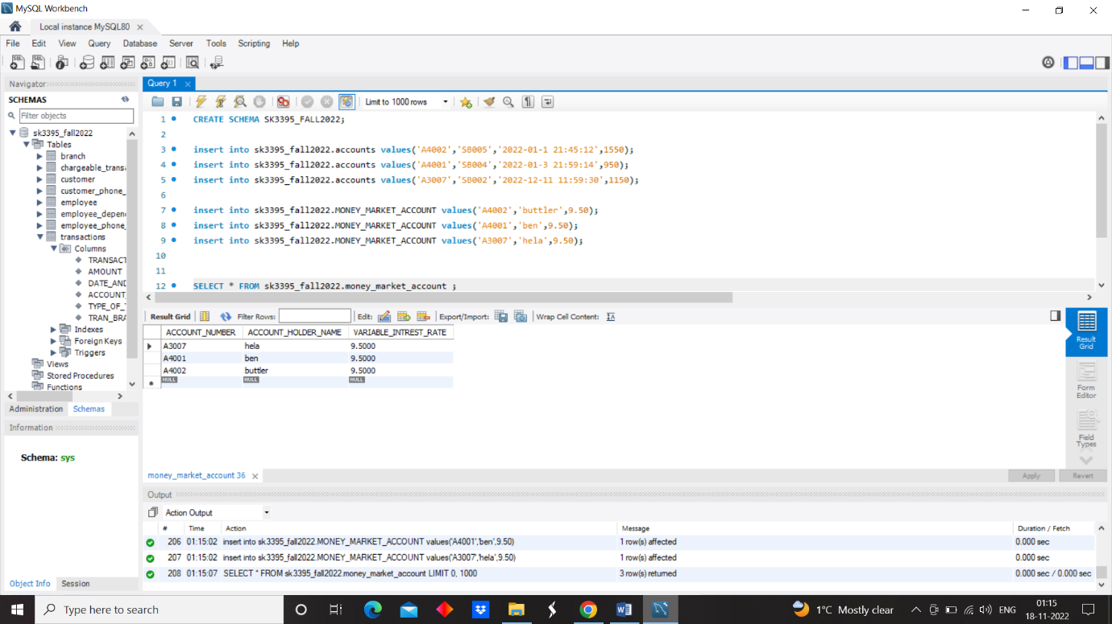

Update money_market_account set Account_holder_name=’stokes’ where Account_holder_name=”buttler”.

Delete from money_market_account where Account_holder_name=’buttler’.

**CREATE A TABLE ORGINATE**

create table sk3395_fall2022.ORGINATE (

ACCOUNT_NUMBER VARCHAR(50) NOT NULL,

LOAN_NUMBER VARCHAR(50) NOT NULL,

BRANCH_ID VARCHAR(50) NOT NULL,

FOREIGN KEY(BRANCH_ID) REFERENCES sk3395_fall2022.BRANCH(BRANCH_ID) ON DELETE CASCADE,

FOREIGN KEY(ACCOUNT_NUMBER, LOAN_NUMBER) REFERENCES sk3395_fall2022.loan_account(ACCOUNT_NUMBER, LOAN_NUMBER) ON DELETE CASCADE,

PRIMARY KEY( ACCOUNT_NUMBER,LOAN_NUMBER,BRANCH_ID)

);

INSERT INTO sk3395_fall2022.orginate values('A3300','LN3242','SB005');

INSERT INTO sk3395_fall2022.orginate values('A5525','LN3422','SB004');

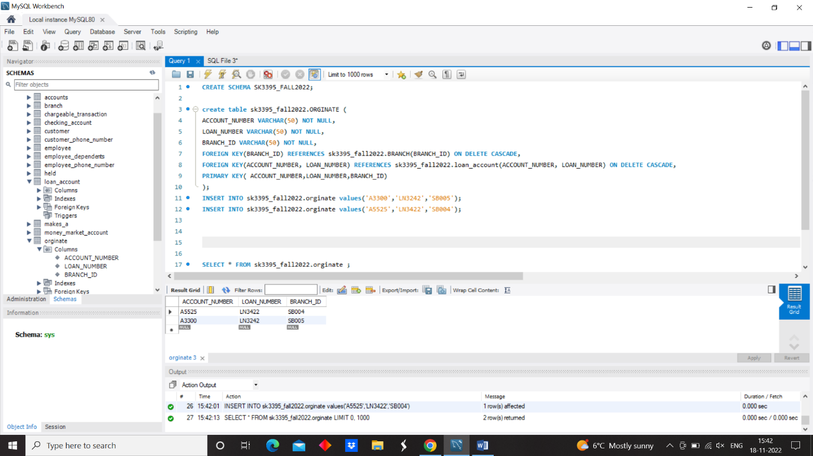

**CREATE A TABLE MAKES_A**

create table sk3395_fall2022.MAKES_A (

ACCOUNT_NUMBER VARCHAR(50) ,

MK_CUST_SSN VARCHAR(50),

MK_TRANSACTION_CODE VARCHAR(50),

FOREIGN KEY(MK_TRANSACTION_CODE) REFERENCES sk3395_fall2022.transactions(TRANSACTION_CODE) ON DELETE CASCADE,

FOREIGN KEY(MK_CUST_SSN) REFERENCES sk3395_fall2022.customer(CUST_SSN) ON DELETE CASCADE,

FOREIGN KEY(ACCOUNT_NUMBER) REFERENCES sk3395_fall2022.accounts(UNIQUE_ACCOUNT_NUMBER) ON DELETE CASCADE,

PRIMARY KEY( ACCOUNT_NUMBER,MK_TRANSACTION_CODE,MK_CUST_SSN) );

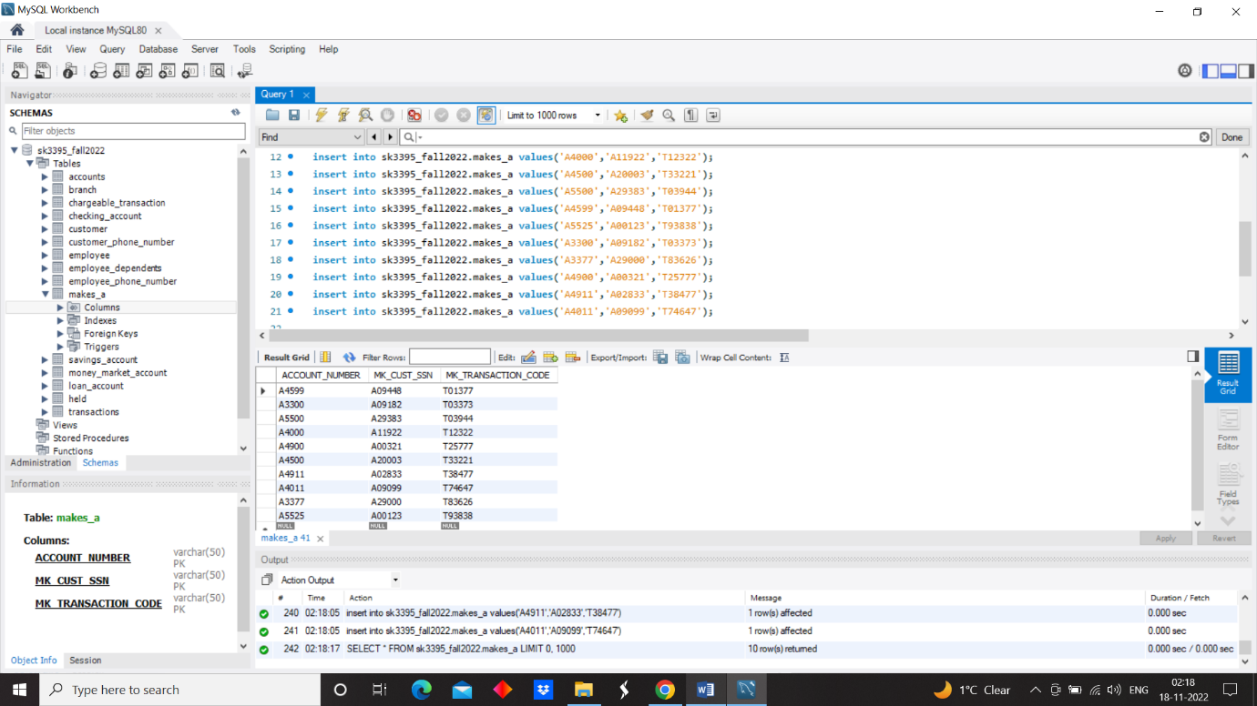

insert into sk3395_fall2022.makes_a values('A4000','A11922','T12322');

insert into sk3395_fall2022.makes_a values('A4500','A20003','T33221');

insert into sk3395_fall2022.makes_a values('A5500','A29383','T03944');

insert into sk3395_fall2022.makes_a values('A4599','A09448','T01377');

insert into sk3395_fall2022.makes_a values('A5525','A00123','T93838');

insert into sk3395_fall2022.makes_a values('A3300','A09182','T03373');

insert into sk3395_fall2022.makes_a values('A3377','A29000','T83626');

insert into sk3395_fall2022.makes_a values('A4900','A00321','T25777');

insert into sk3395_fall2022.makes_a values('A4911','A02833','T38477');

insert into sk3395_fall2022.makes_a values('A4011','A09099','T74647');

**CREATE A TABLE HELD**

create table sk3395_fall2022.HELD (

ACCOUNT_NUMBER VARCHAR(50) ,

CUST_SSN VARCHAR(50),

FOREIGN KEY(CUST_SSN) REFERENCES sk3395_fall2022.customer(CUST_SSN) ON DELETE CASCADE,

FOREIGN KEY(ACCOUNT_NUMBER) REFERENCES sk3395_fall2022.accounts(UNIQUE_ACCOUNT_NUMBER) ON DELETE CASCADE,

PRIMARY KEY( ACCOUNT_NUMBER,CUST_SSN)

);

insert into sk3395_fall2022.HELD values('A4000','A11922');

insert into sk3395_fall2022.HELD values('A4500','A20003');

insert into sk3395_fall2022.HELD values('A5500','A29383');

insert into sk3395_fall2022.HELD values('A4599','A09448');

insert into sk3395_fall2022.HELD values('A5525','A00123');

insert into sk3395_fall2022.HELD values('A3300','A09182');

insert into sk3395_fall2022.HELD values('A3377','A29000');

insert into sk3395_fall2022.HELD values('A4900','A00321');

insert into sk3395_fall2022.HELD values('A4911','A02833');

insert into sk3395_fall2022.HELD values('A4011','A09099');

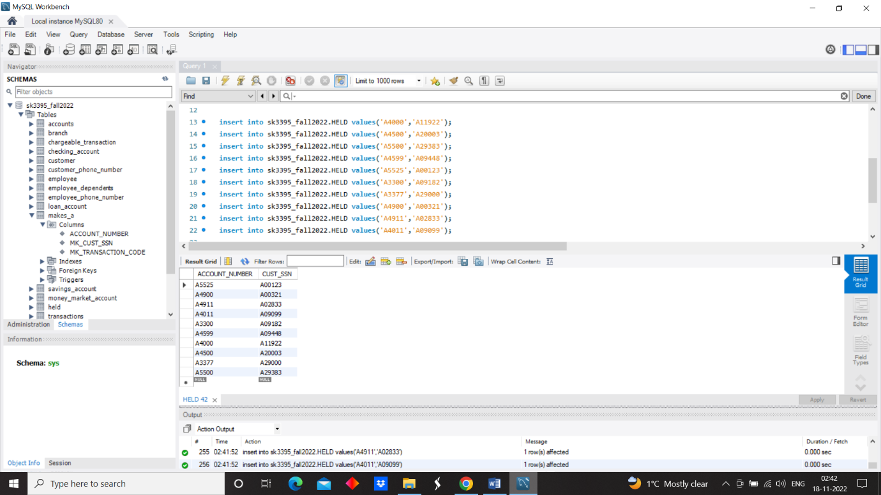

**SQL QUERIES**

1) SELECT THE TOTAL SUM OF THE AMOUNT OF EACH TYPE OF TRANSACTION IN TRANSACTIONS TABLE?

A) select SUM(AMOUNT),TYPE_OF_TRANSACTION from TRANSACTIONS group by TYPE_OF_TRANSACTION ;

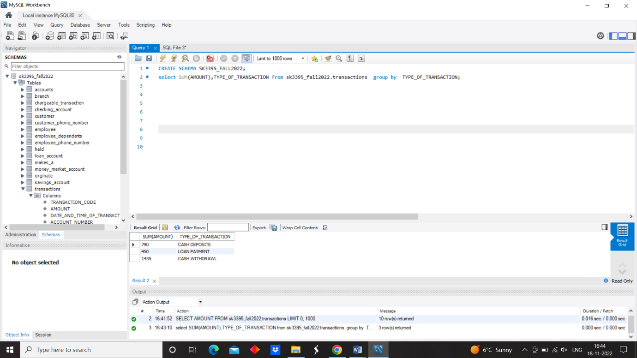

2) SELECT ONLY THE TYPE_OF_TRANSACTIONS WHERE SUM OF THE TOTAL AMOUNT IS GREATER THAN 500?

A) select SUM(AMOUNT),TYPE_OF_TRANSACTION from TRANSACTIONS group by TYPE_OF_TRANSACTION HAVING SUM(AMOUNT)>=500;GNVG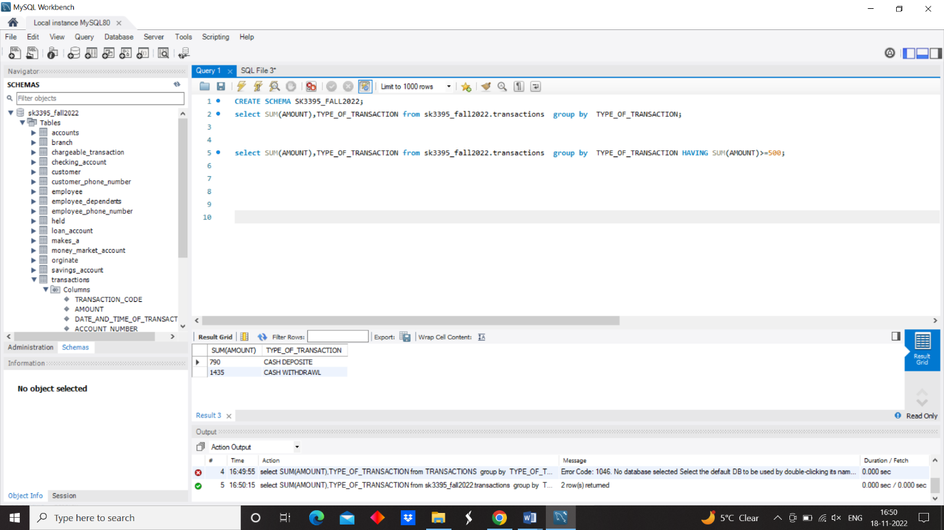

3) SELECT ALL THE ACCOUNT_NUMBERS, TRANSACTION_CODE, and TYPE_OF_TRANSACTIONS WHERE AMOUNT IS GREATER THAN 350?

A) SELECT ACCOUNT_NUMBER, TRANSACTION_CODE, TYPE_OF_TRANSACTION FROM TRANSACTIONS WHERE AMOUNT IN (SELECT AMOUNT FROM TRANSACTIONS WHERE AMOUNT>=350);

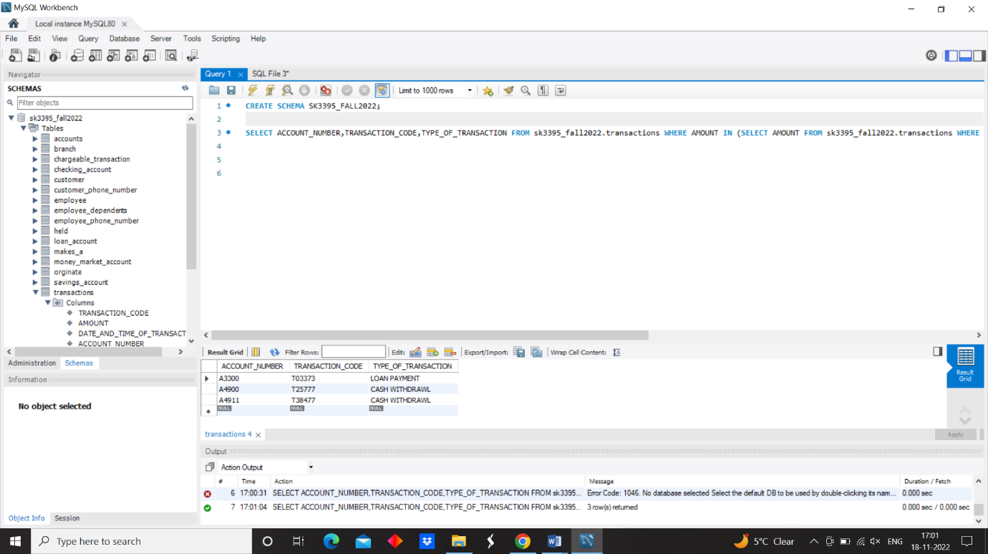

4) SELECT ALL THE DATE AND TIME OF TRANSACTIONS OF EACH ACCOUNT WHICH HAS A ACCOUNT BALANCE OF GRATER THAN 2500?

A) SELECT DATE_AND_TIME_OF_TRANSACTION FROM TRANSACTION WHERE ACCOUNT_NUMBER= ALL (SELECT UNIQUE_ACCOUNT_NUMBER FROM ACCOUNTS WHERE ACCOUNT_BALANCE>=2500);

